**PROJECT – 3**

**Deploy flask python web application in AWS cloud**

PART – 1

1. Create IAM User, Assign Roles/Policies, Create VPC, EC2 Instance, with SG-port number 8000

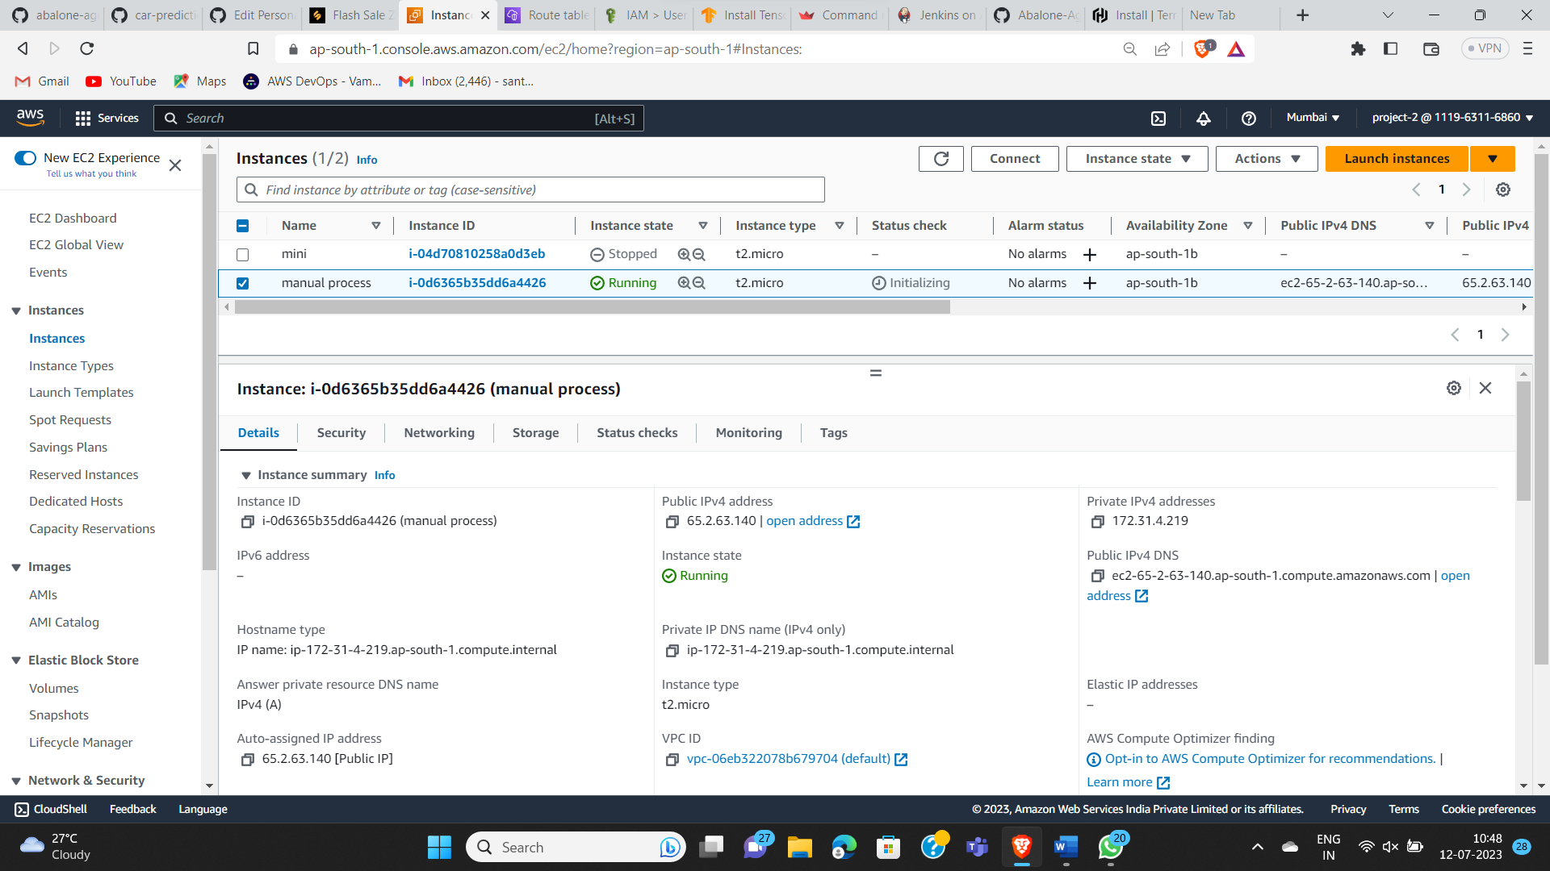

1. Connect to EC2 instance via **ssh -i pem filename username@public ip address**

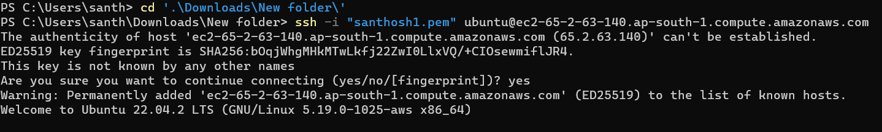

1. Now update the ubuntu machine via **sudo apt update & sudo apt-get full-upgrade -y**

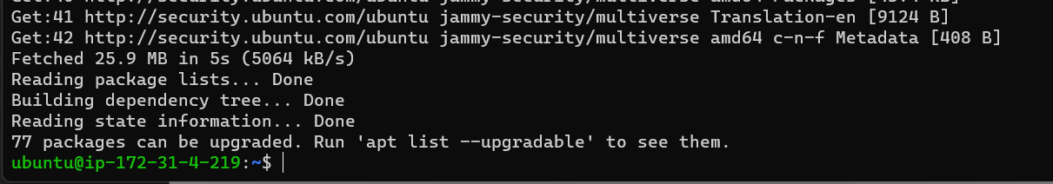

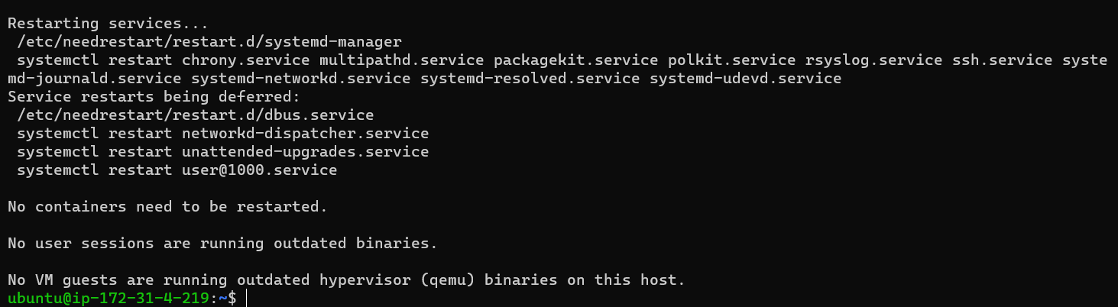

1. Now install the python package requirements by using command

**Sudo apt install python3-pip**

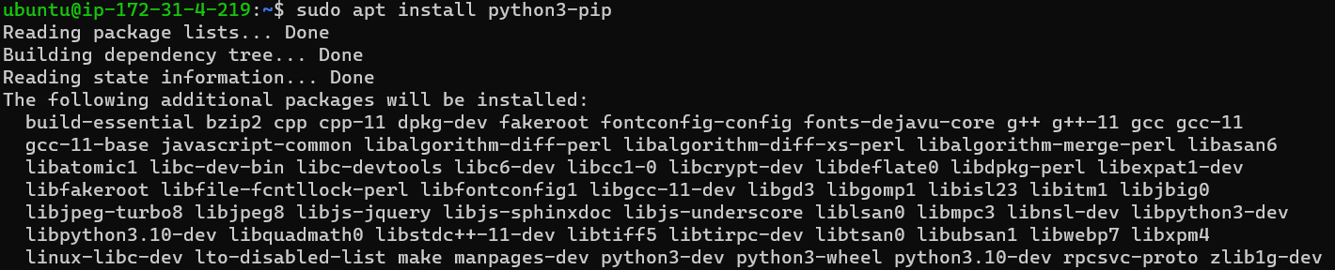

1. Now install python3 by using – **sudo apt install python3**

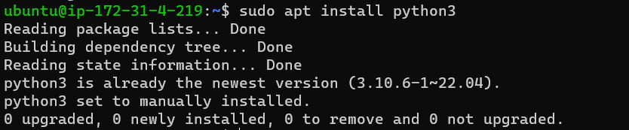

1. Clone the project source code from GitHub to our local machine

-------->git clone <project URL>

Git clone[**https://github.com/santhosh-1105/abalone-age-prediction.git**](https://github.com/santhosh-1105/abalone-age-prediction.git)

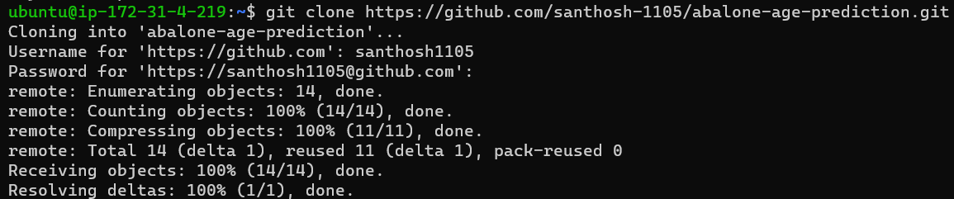

1. Now go to the directory by using- cd and then go into the directory and see the files.

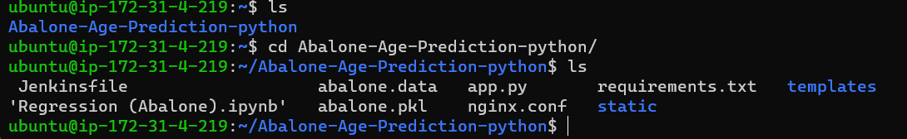

1. Now install the requirements by using – **pip install -r requirements.txt**

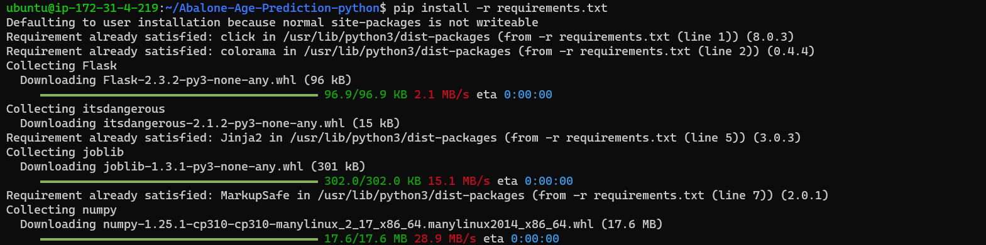

1. Now we have to edit the app.py file. In that we have to change host as (0.0.0.0)

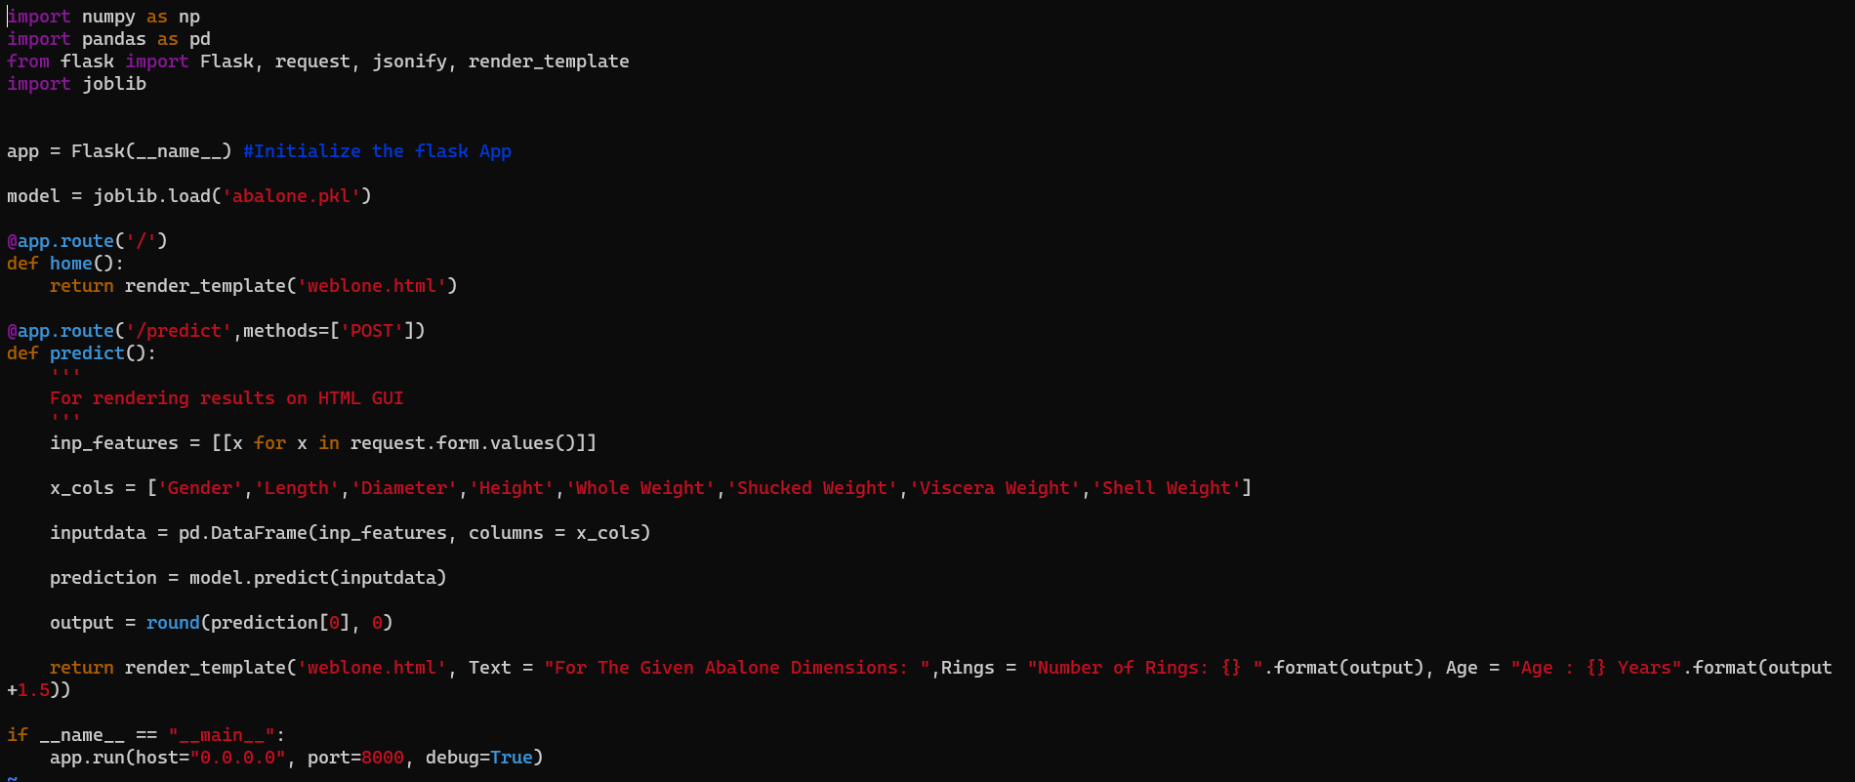

1. After we have to run the app.py file

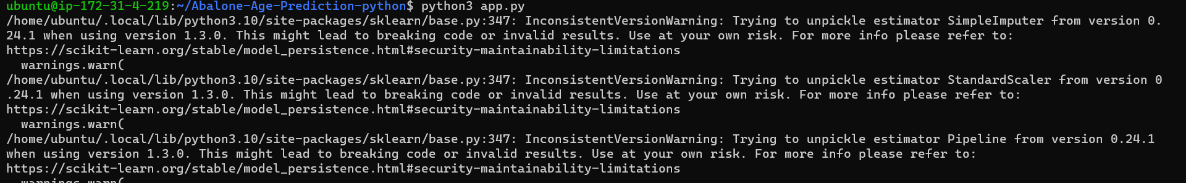

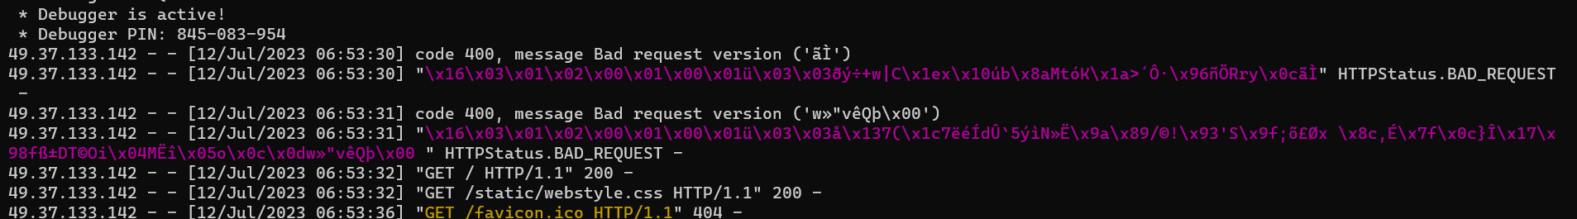

1. Then we have to go to AWS console and copy the public ip address then we get the output.

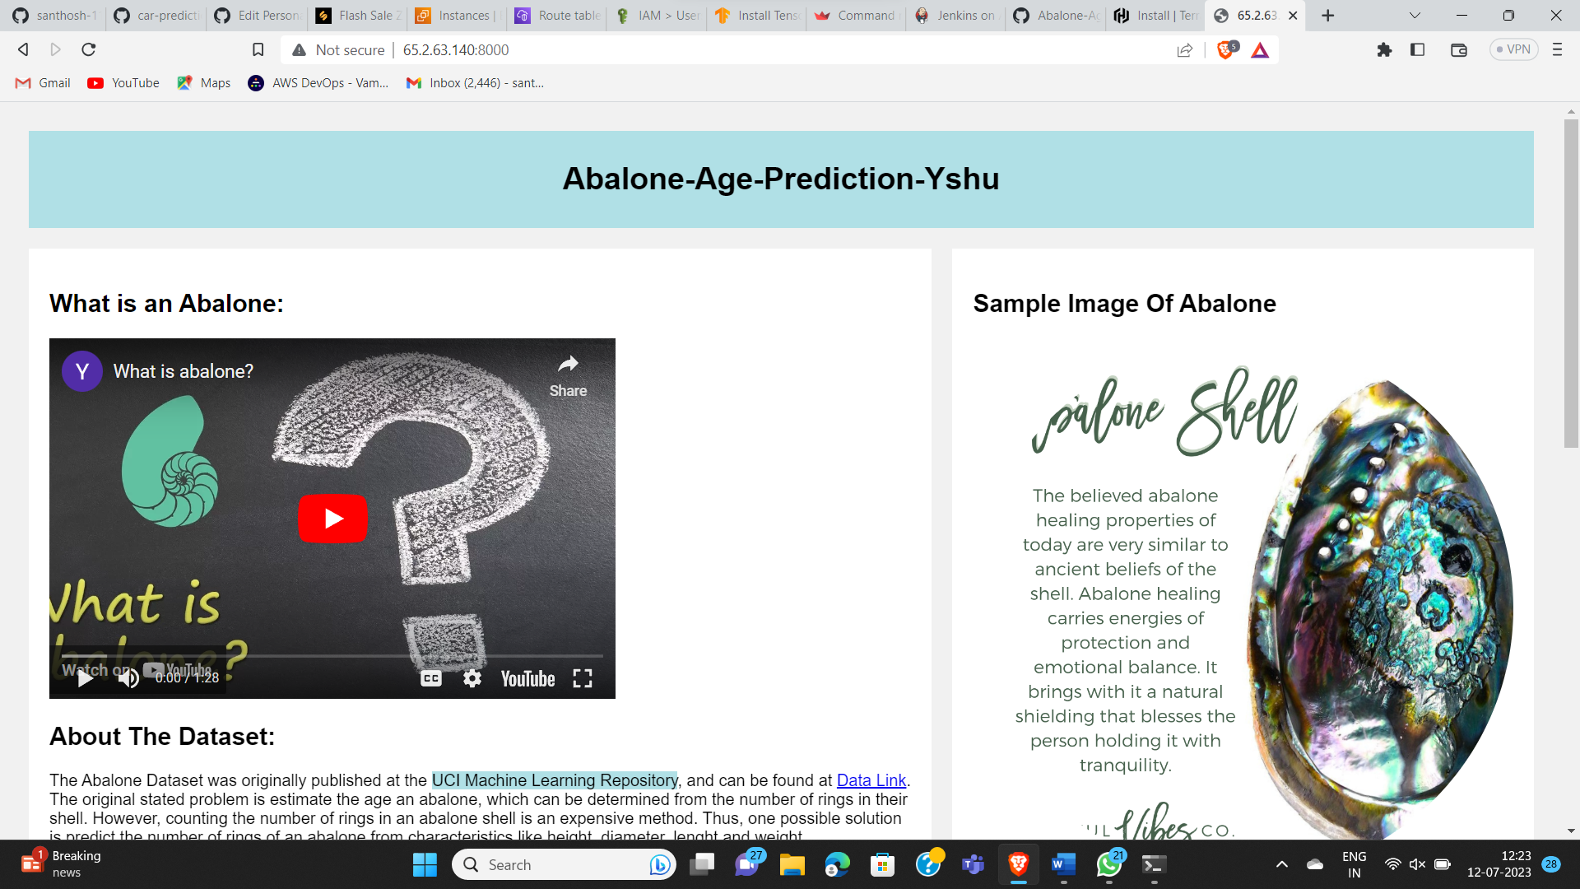

PART – 2

1. Create userdata file using Part – 1 and create data.sh file

Below files are the userdata file which includes data.sh file and also create the terraform files



1. Now we have to install the terraform

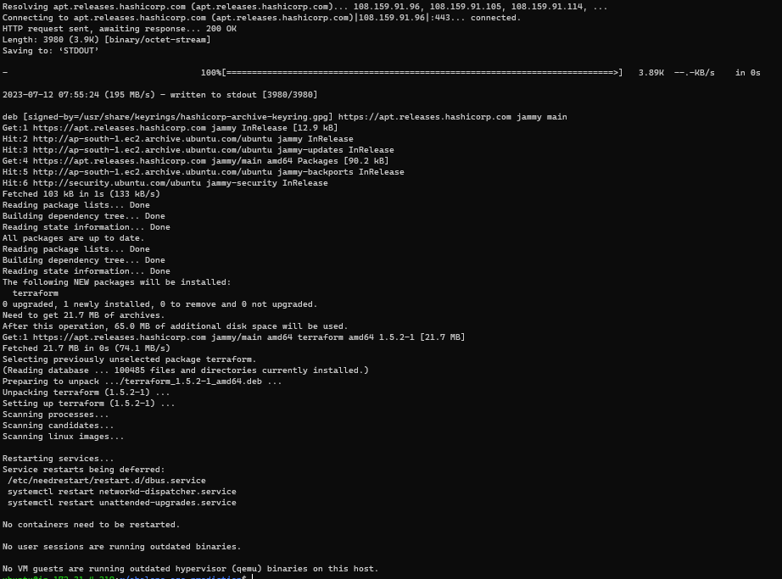

1. Now we have to initiate, validate, plan, apply by using commands

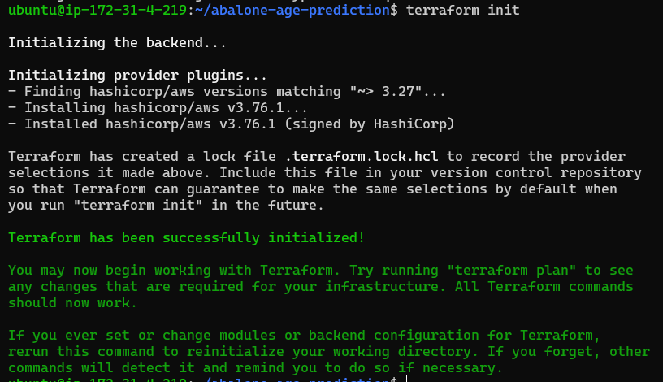 Terraform init, Terraform validate, Terraform plan, Terraform apply





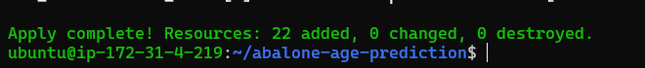

1. Now go to the AWS console and check whether they are cleated or not

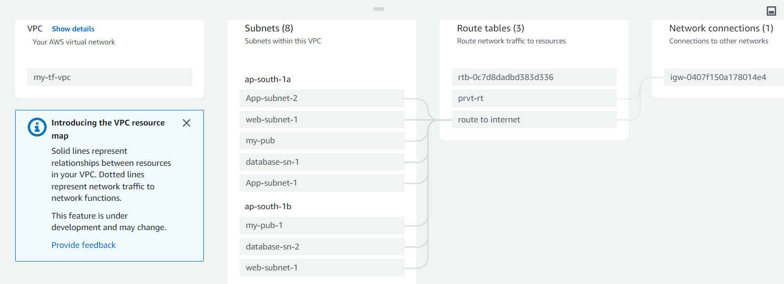

1. Now go to the created instance which was created by the main instance

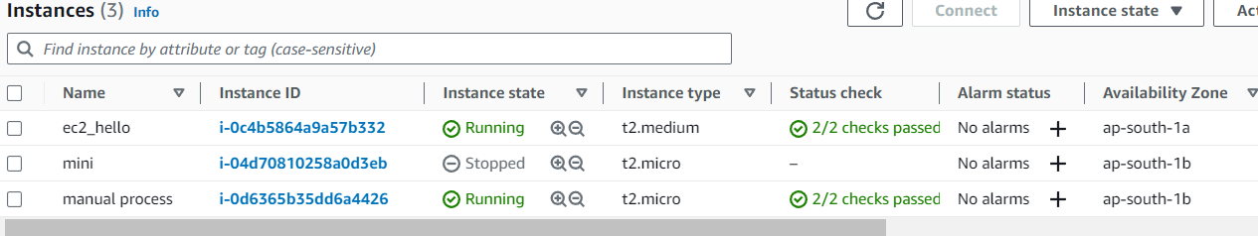

1. Now copy ip address of the newly created instance(ec2_hello) and check the output

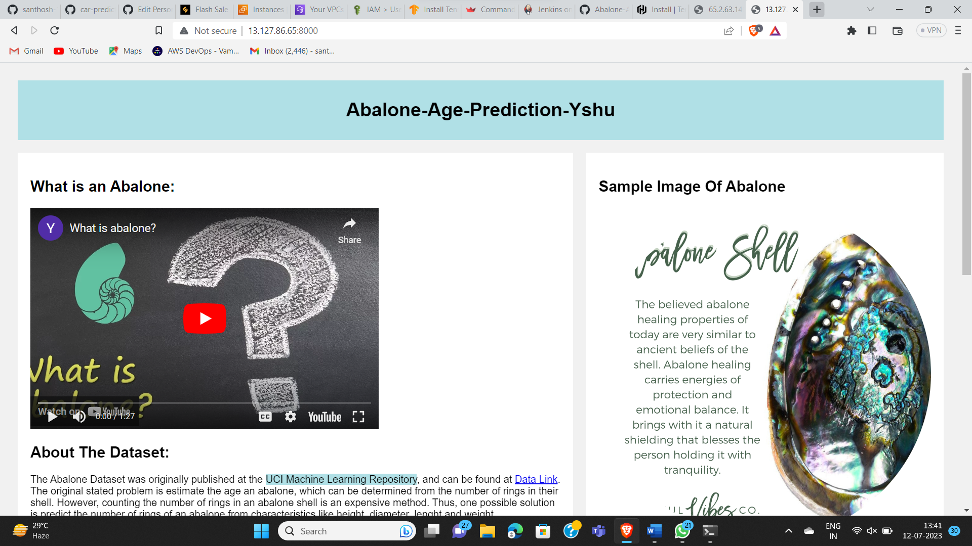

1. After exit from terminal we have see the output by using command- screen -d -m python3 app.py. Which was written in the data.sh file shown below

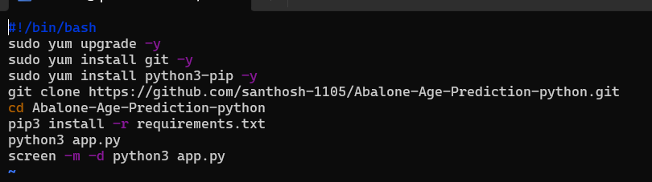

PART – 3

1. Create and install Jenkins in the instance and copy the public ip and browse it with 8080 port number

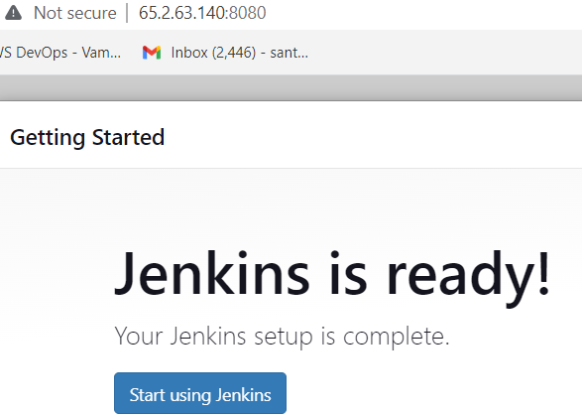

1. use Part - 1 steps and test, build and deploy in manual procedure.

* Create a new job in freestyle project

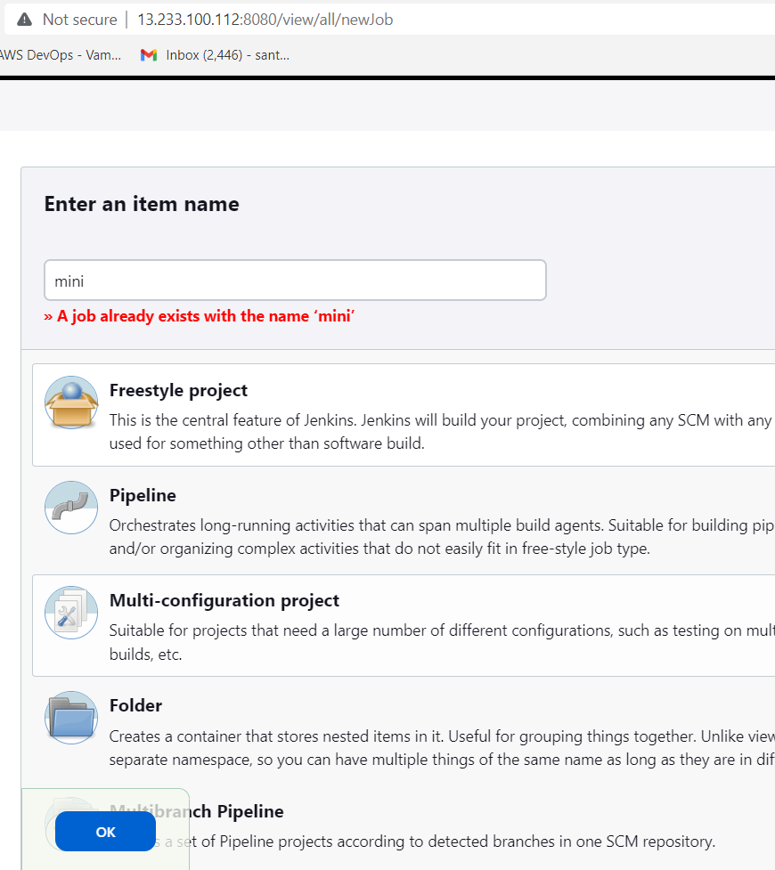

* Now clone the git repo from the git hub as shown below

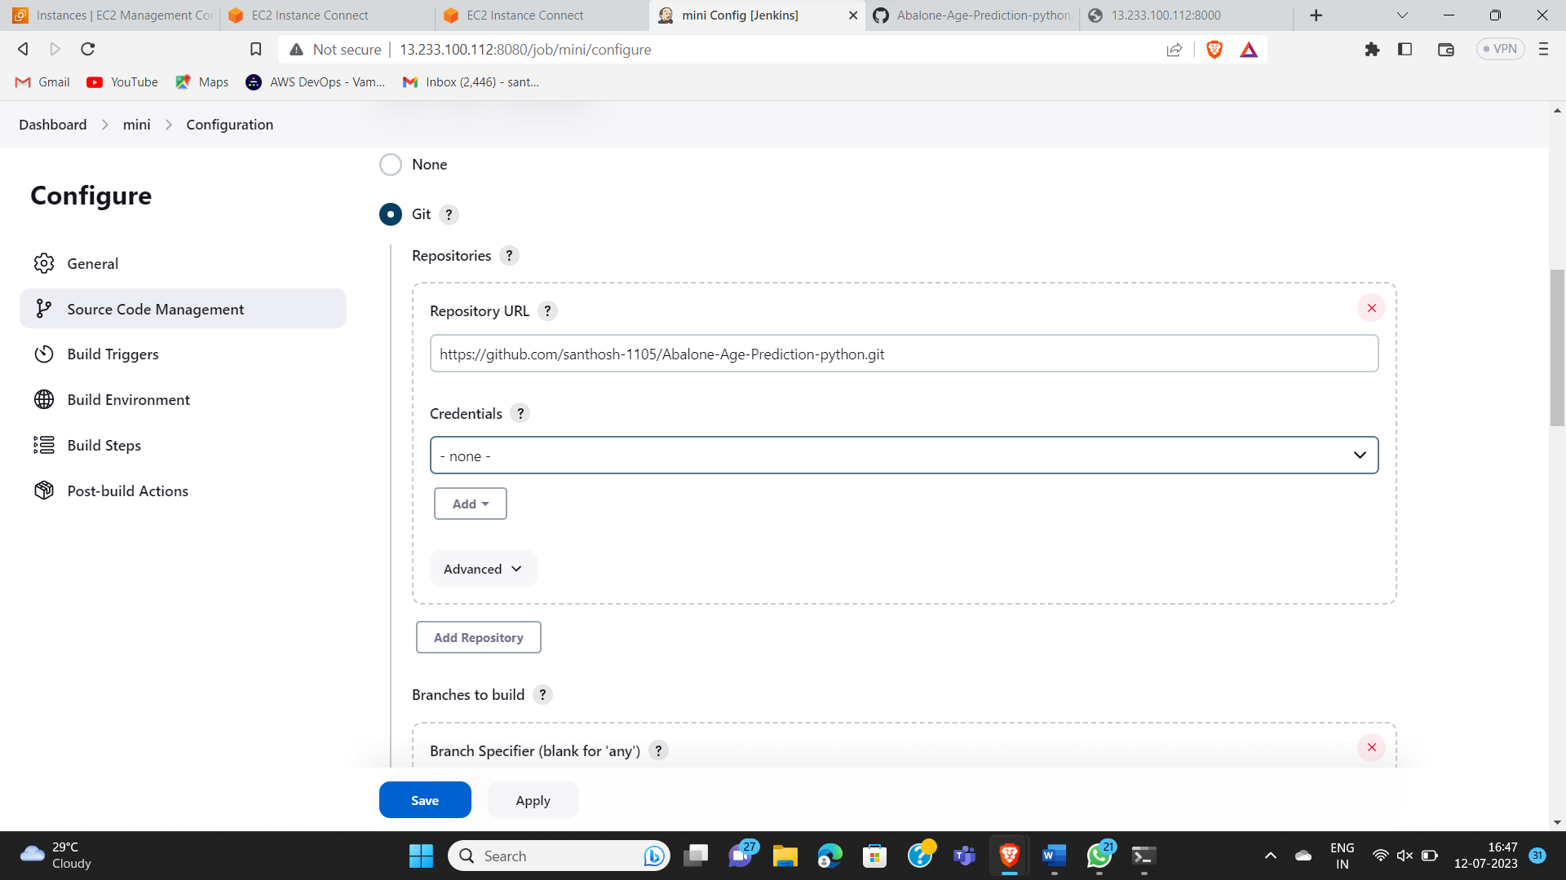

* Now go to the execute shell and enter the commands as seen in below image

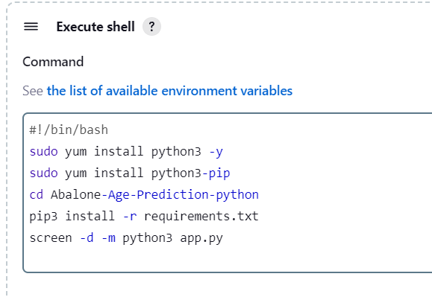

1. Now we have to apply and save it

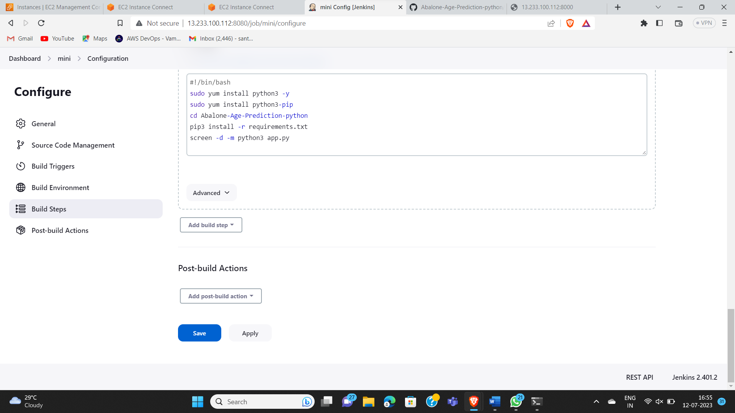

1. After apply and save we get a page like shown as below

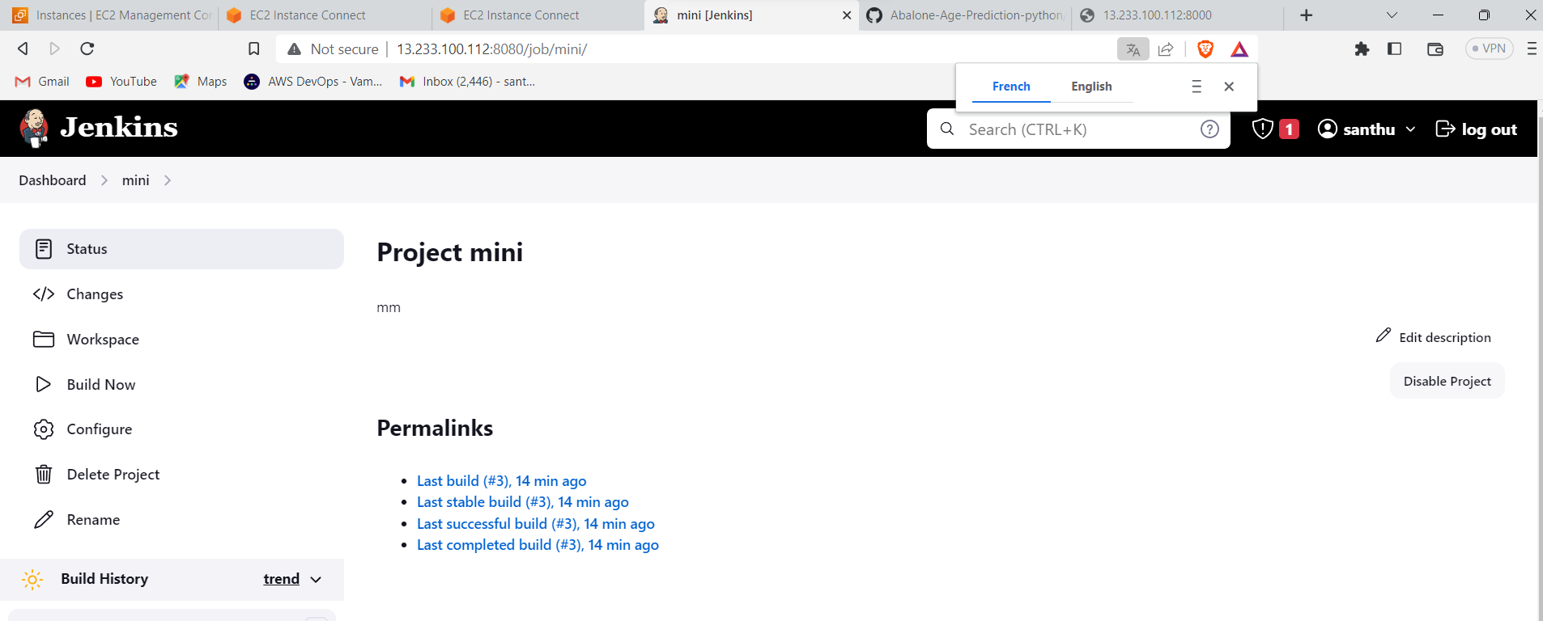

1. Now we have to click on Build Now option then we get the console output as success

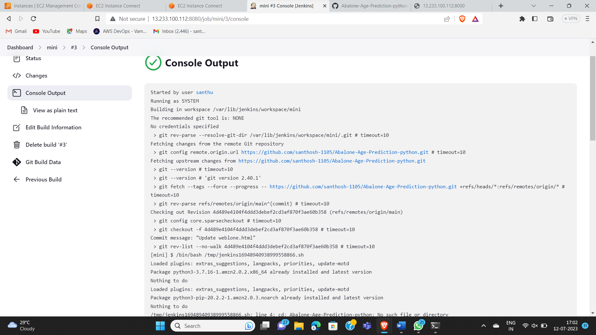

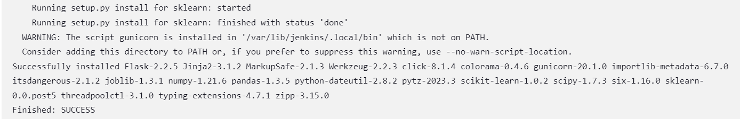

1. Now go to instance and copy the public ip of that instance and browse it with 8000 port number , then we get the output of the [Abalone-Age-Prediction-python](https://github.com/santhosh-1105/Abalone-Age-Prediction-python.git)

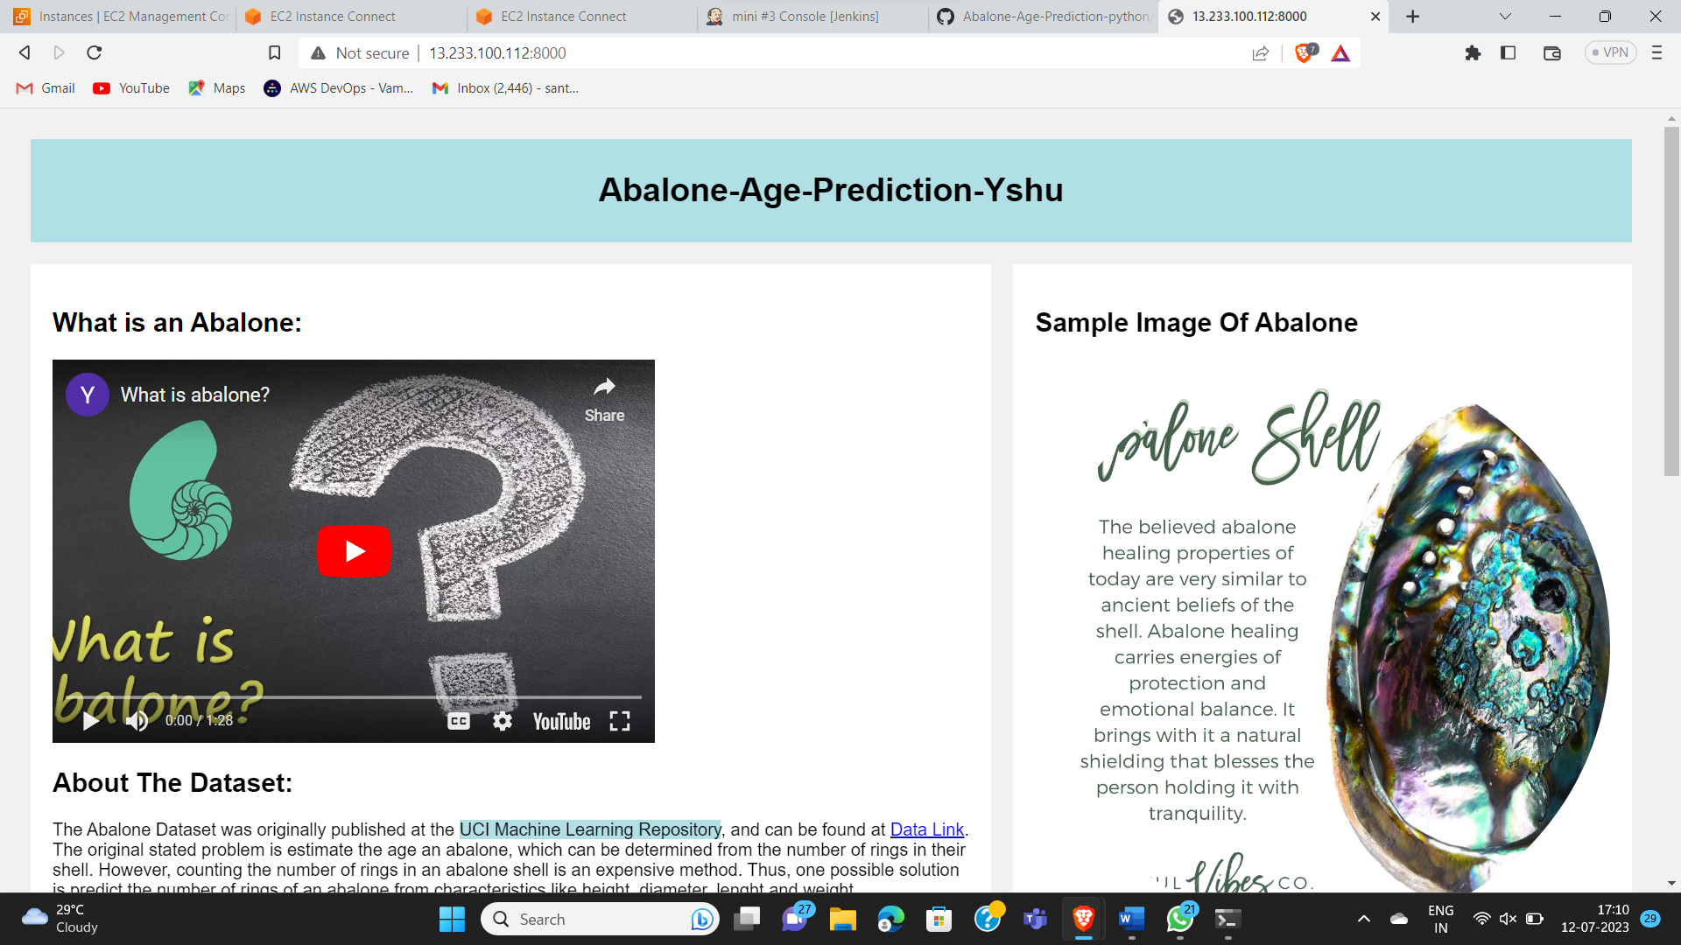

PART – 4

1. Create and install Jenkins in the instance and copy the public ip and browse it with 8080 port number



* Create a new job in freestyle project

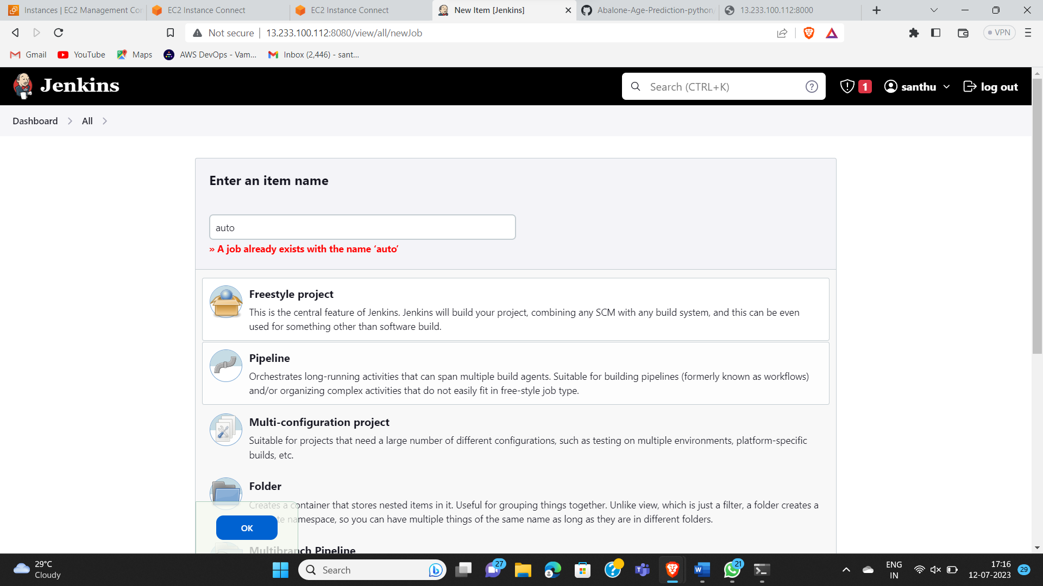

* Now clone the git repo from the git hub as shown below and the repo must be in private after clone we have to give the credentials for security purpose we can see in the below image

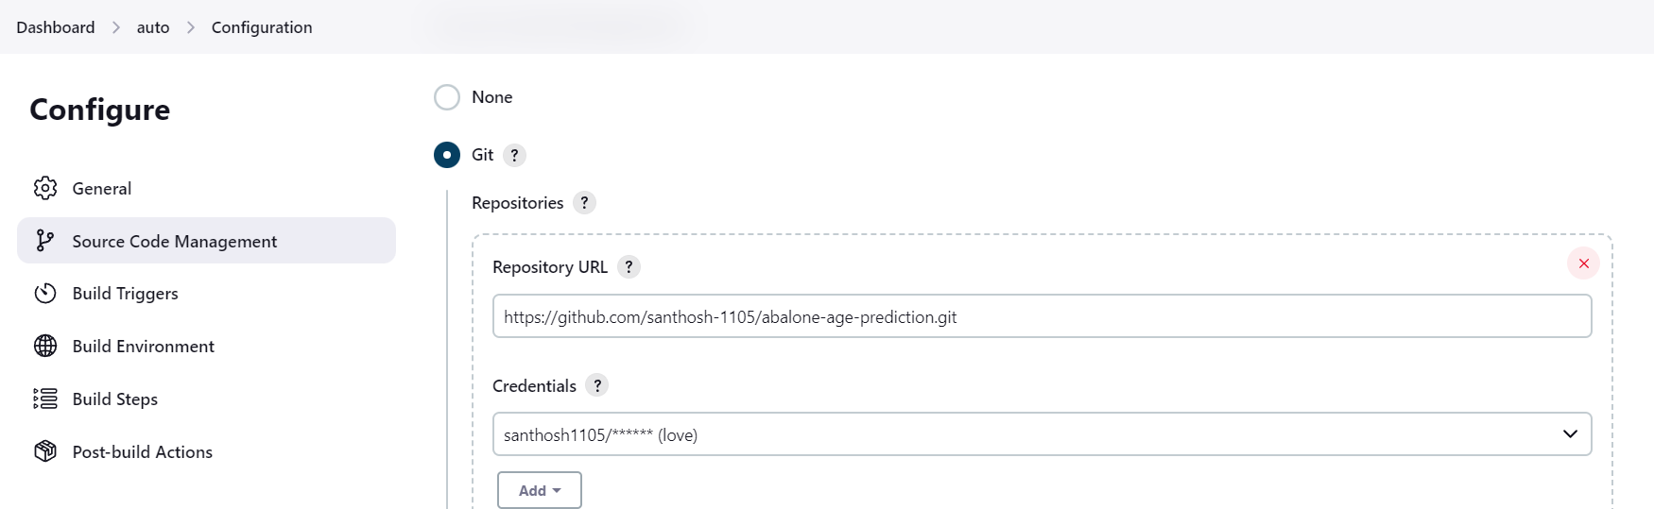

* Now go to the execute shell and enter the commands as seen in below image

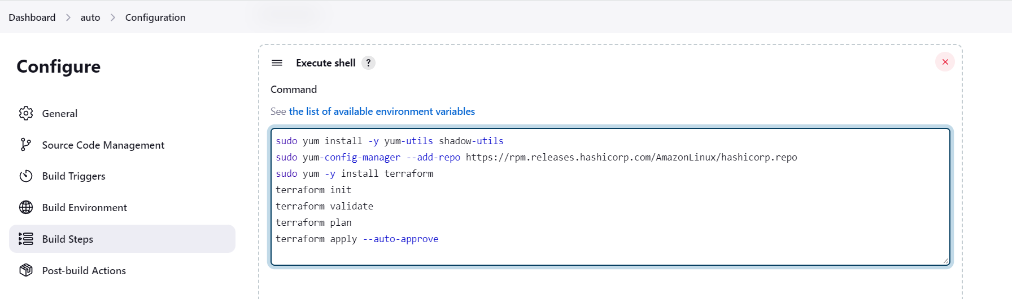

1. Now click on apply and save

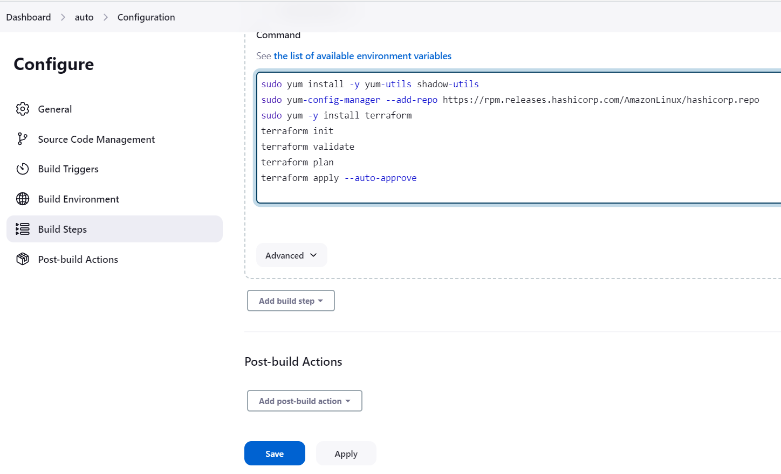

1. After clicking on apply and save we get the page be open like shown below

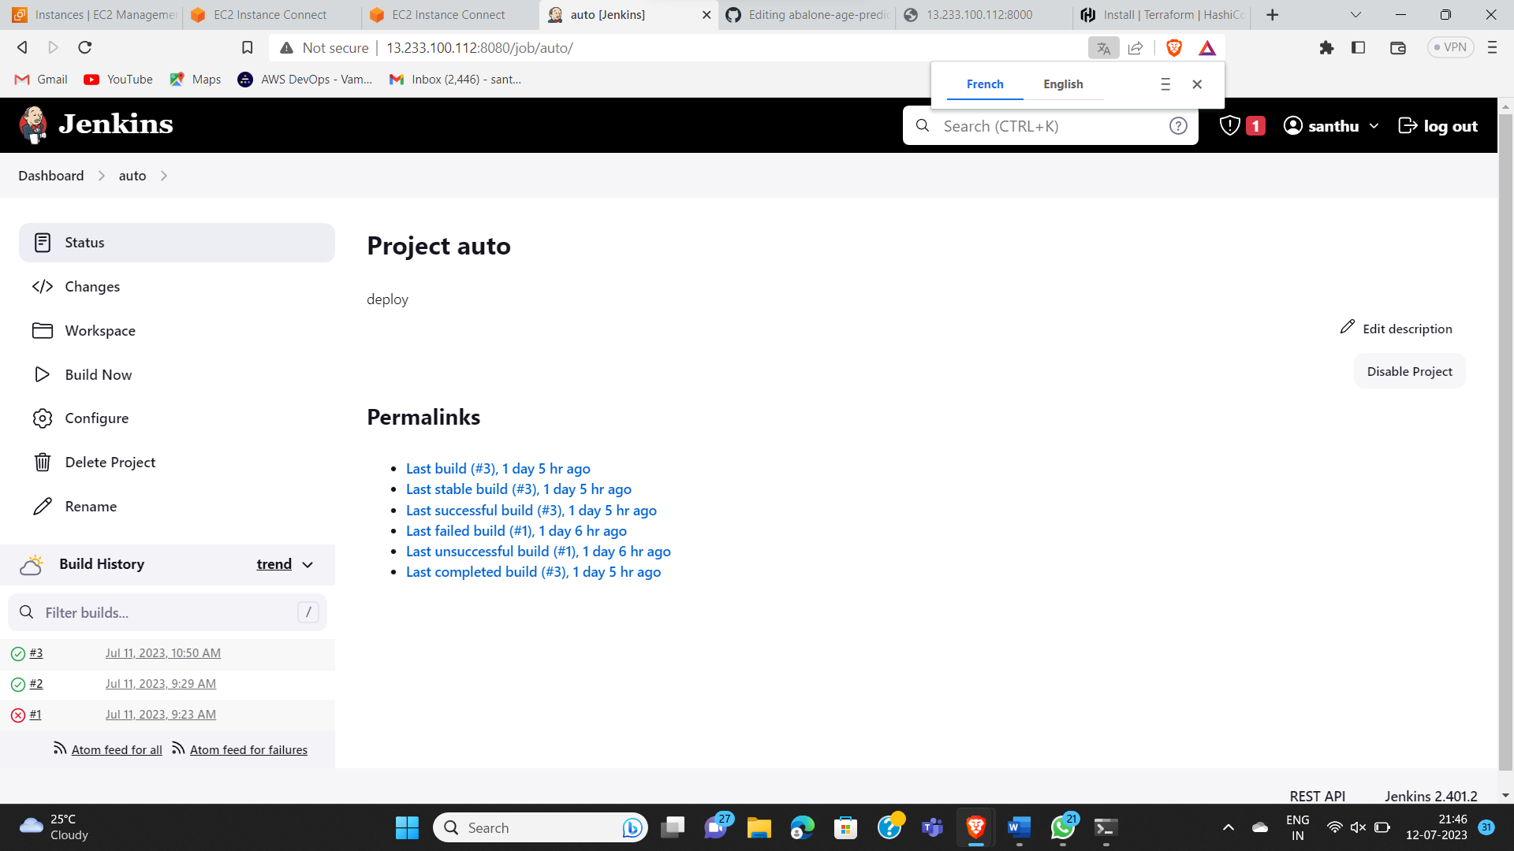

1. Now click on Build Now option then we get the console output as success

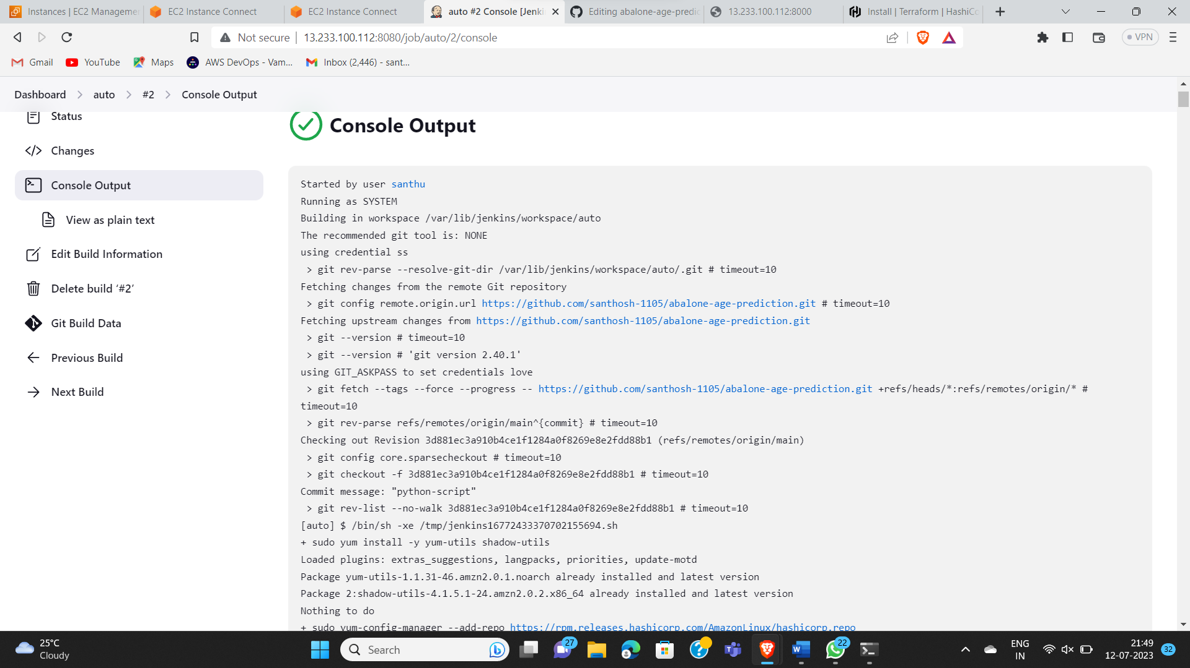



1. Now go to instance and copy the public ip of that instance and browse it with 8000 port number , then we get the output of the [Abalone-Age-Prediction-python](https://github.com/santhosh-1105/Abalone-Age-Prediction-python.git)



PART – 5

1. Now we have run the as automation procedure by using

* **Webhooks**
* **PollSCM**
* **Build Periodically**
* **Webhooks:**

1. Now go to the GitHub repo

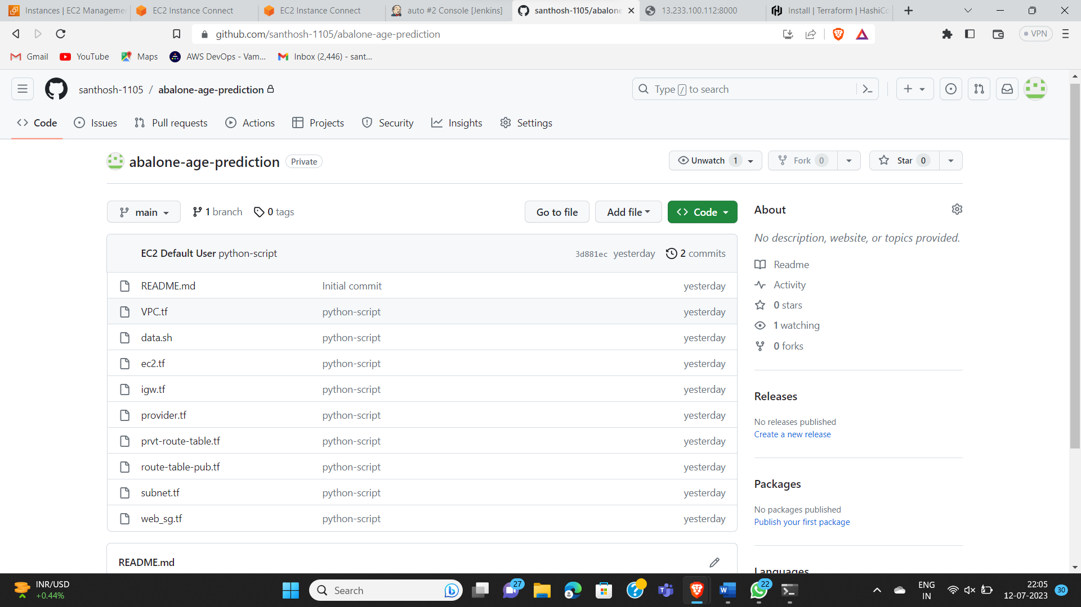

1. In this repo go into the setting option

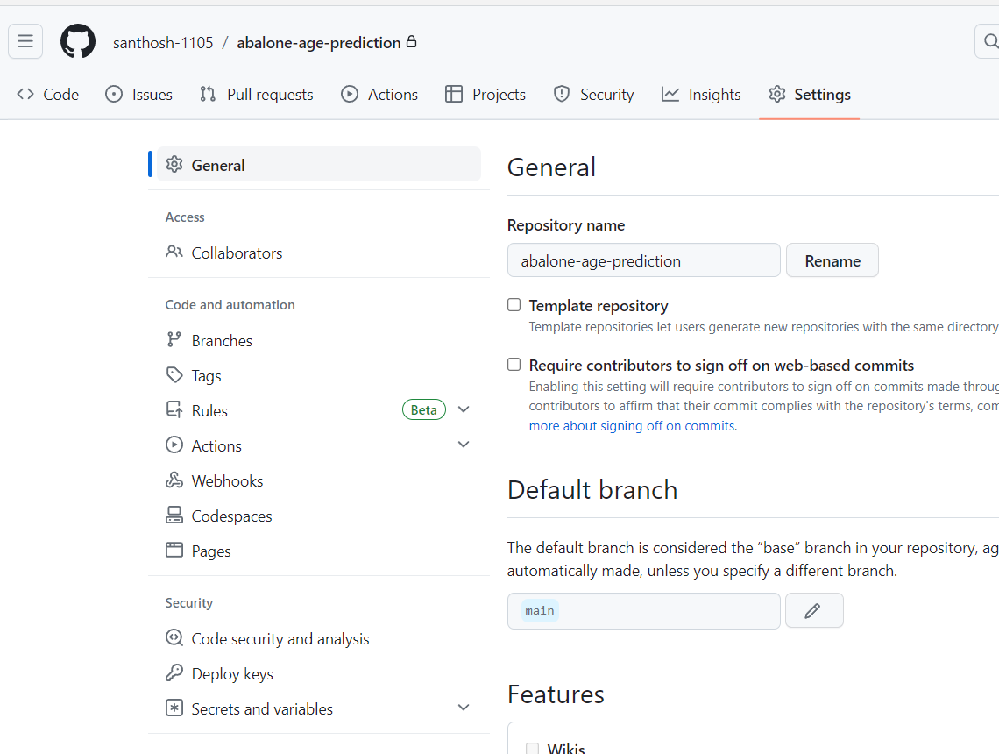

1. Now select the webhooks option and go into that’s page. The page will seen like,

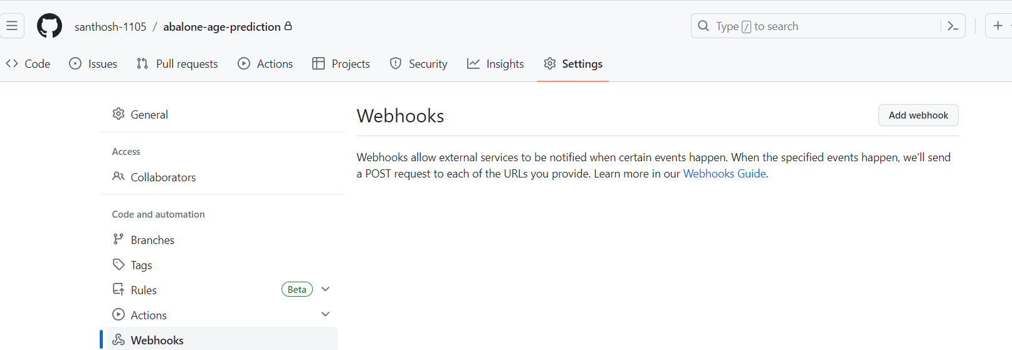

1. Now click on “Add Webhooks” which was seen in the above image, now it will ask us the GitHub password.

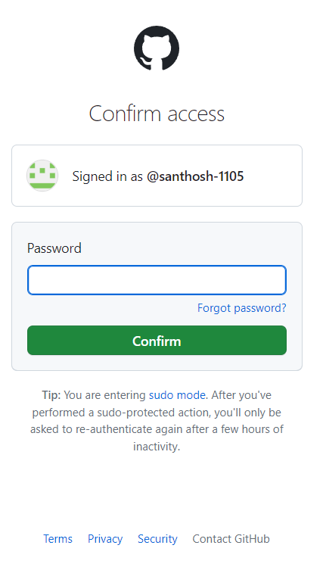

1. Then the page is to be open like,

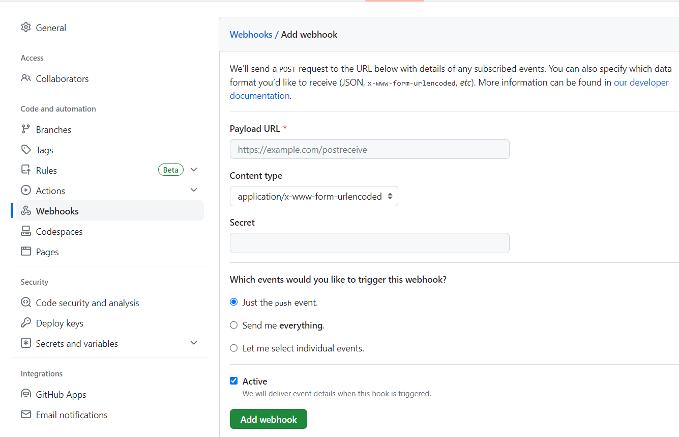

1. In the above image we have to give the Payload URL as “Jenkins server URL/github-webhook/”
2. And then content type will be in the “Json” mode after that we have to enable the send me **everything**

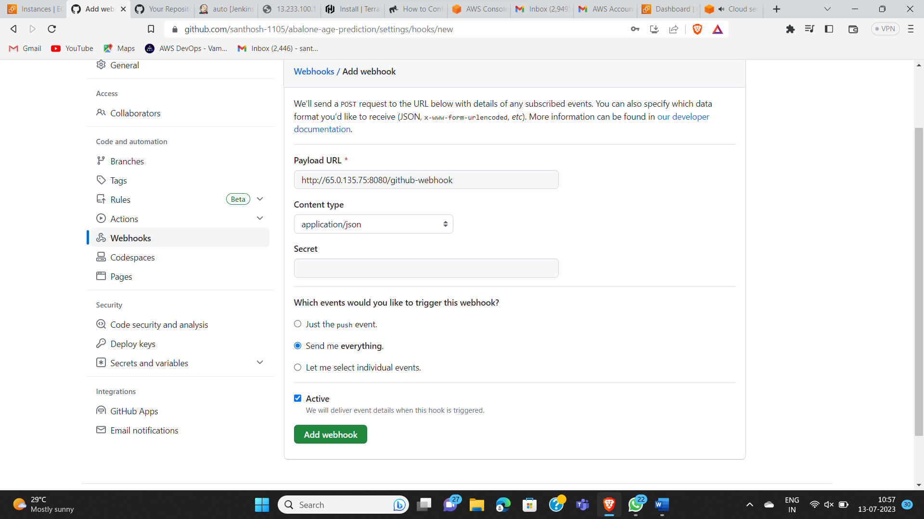

1. Now we get the triggering if we change any content in the repo as it build automation like

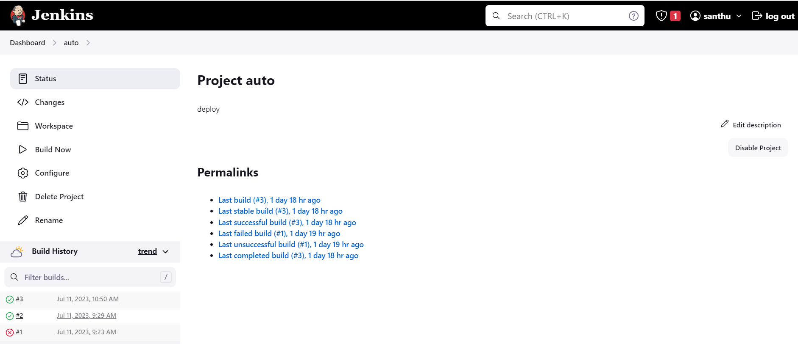

* **PollSCM:**

1. **Go into the Jenkins server and select the PollSCM for the triggering purpose and enter the H/3 * * * in the Build Triggers in that select the Poll SCM**

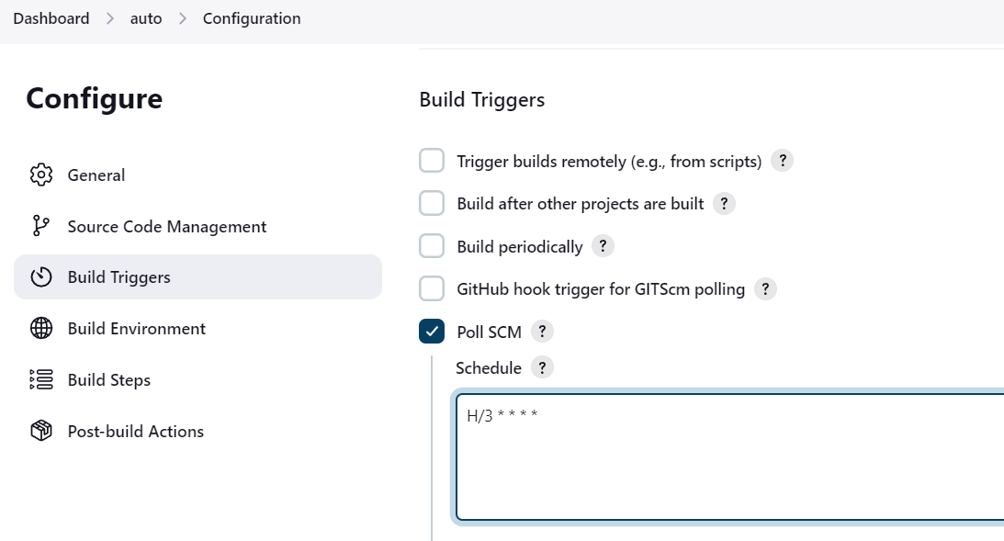

1. **While using the Poll SCM it will trigger every 3-min if we change any content in the git repo it will build job automatically.**
2. **If we didn’t do any changes in the git repo it will not trigger but it circulate and check the content whether it change or not .**

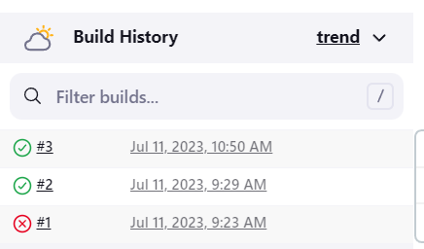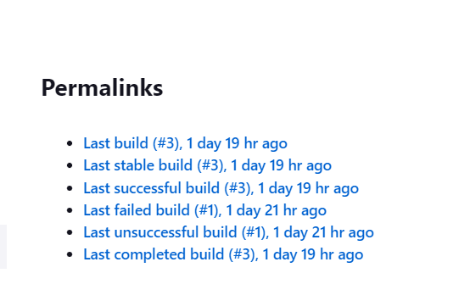

* **Build Periodically**

1. **Go to the Jenkins server and in that go through the Build trigger in that we have to select the “Build periodically”**
2. **Enter the value time that at which time to trigger periodically whether it changes or not it automatically build its job for every 5-min**

